WEEK 3
Week Ending: 19-09-2025 |  | DAY: |  | Subject: COMPUTING
Duration: 50mins |  |  |  | Strand: Introduction to computing
Class: B7 |  | Class Size: |  | Sub Strand: Components of Computers and Computer Systems
Content Standard:  B7.1.1.1. Examine the parts of a computer |  |  | Indicator:  B7.1.1.1.3 Examine the uses of the output devices: graphing plotter, data and multimedia projectors as well as pico projector |  |  | Lesson:  1 of 1
Performance Indicator:  Learners can identify at least three output devices and explain the primary function of each identified output device. |  |  |  |  | Core Competencies:  Communication and Collaboration, Critical Thinking and Problem solving
References: Computing Curriculum Pg.
Keywords: output device, monitor, printer, speaker, projector, data
Phase/Duration | Learners Activities |  |  |  |  |  | Resources
PHASE 1: STARTER | Begin by asking learners to look around the the computer lab and identify any devices they see that show information or images, play sound, or produce physical copies of documents.  Write their responses on the board.  Display pictures of a monitor, printer, speaker, and projector. Ask learners if they know what these devices are called and what they are used for.
PHASE 2: NEW LEARNING | Introduce the concept of output devices. Explain that output devices are hardware components that convey information to the user from the computer. These devices present data in a variety of forms, such as visuals, sound, or printed materials.  Show images of different output devices one by one and ask learners to name them. Write the names next to each picture on the board.  Guide learners to explain the functions of the devices  - Monitor: a monitor displays visual output from the computer. It shows images, videos, and text.  - Printer: a printer produces a physical copy of digital documents, pictures, or other data from the computer.  - Speaker: speakers output sound from the computer, allowing users to hear music, voice, and other audio.  - Projector: a projector displays images or videos on a larger screen, typically for presentations or classroom instruction.  If available, demonstrate how each output device works by showing a short video or using actual devices in the classroom.  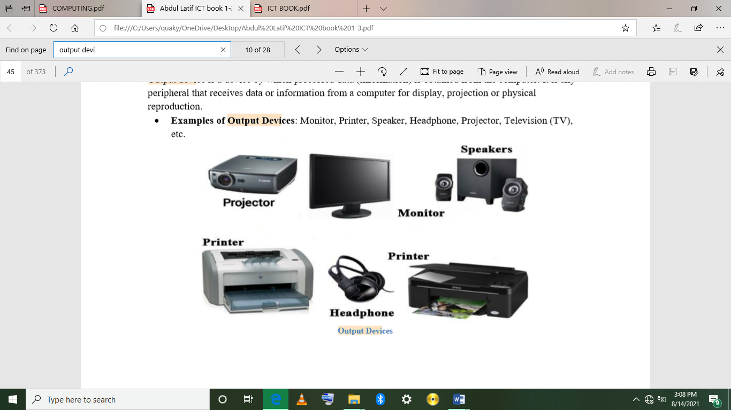  Distribute pictures of various output devices (some discussed, some not) and ask learners to work in pairs to name the device and describe its function.  For learners who need extra help, provide a word bank on the worksheet or pair them with a peer for additional support.  Assessment  - Name two output devices used to display visual information.  - What is the primary function of a printer? |  |  |  |  |  | Pictures or actual examples of output devices (monitor, printer, speakers, projector)
PHASE 3: REFLECTION | - Which output device is used for playing sound?  - Explain how a projector is different from a monitor.  Use peer discussion and effective questioning to find out from learners what they have learnt during the lesson.  Take feedback from learners and summarize the lesson.

Week Ending: 19-09-2025 |  | DAY: |  | Subject: COMPUTING
Duration: 50mins |  |  |  | Strand: Introduction to computing
Class: B7 |  | Class Size: |  | Sub Strand: Components of Computers
Content Standard:  B7.1.1.1. Examine the parts of a computer |  |  | Indicator:  B7.1.1.1.4 Identify magnetic storage devices, portable hard drives/Optical Discs and Drives and discuss their features |  |  |  | Lesson:  1 of 1
Performance Indicator:  Learners can identify different types of storage devices and describe the functions of magnetic storage devices, portable hard drives, and optical discs. |  |  |  |  | Core Competencies:  Communication and Collaboration, Critical Thinking and Problem solving
References: Computing Curriculum Pg.
Keywords: storage device, magnetic, optical, portable, capacity
Phase/Duration | Learners Activities |  |  |  |  | Resources
PHASE 1: STARTER | Begin by asking learners if they have ever used or seen devices that store large amounts of data, such as a computer's hard drive, a USB drive, or a CD/DVD.  Write their responses on the board.  Show pictures of a hard disk drive (HDD), a portable hard drive, and a CD/DVD.  Ask learners if they recognize these devices and what they think each one is used for.
PHASE 2: NEW LEARNING | Introduce the concept of storage devices, explaining that they are used to store digital information. Highlight the three main types of storage devices that will be discussed: magnetic storage devices, portable hard drives, and optical discs/drives.  Ask learners if they know where files and programs are stored on a computer.  Discuss how storage devices play a crucial role in data management.  Guide learners to discuss the storage devices identified  - Magnetic Storage Devices: magnetic storage devices, like hard disk drives (HDDs), use magnetic fields to store data. They are commonly used in computers for storing large amounts of data. Emphasize their capacity and durability.  - Portable Hard Drives: portable hard drives are external storage devices that connect to computers via USB or other ports. They are used for backing up data or transferring large files between devices. Highlight their portability and ease of use.  - Optical Discs/Drives: optical discs, such as CDs, DVDs, and Blu-ray discs, store data using laser technology. Optical drives are the devices that read and write data on these discs. Discuss their use in storing media files, software, and backups.  Show how each type of storage device connects to a computer and how data can be stored or retrieved from these devices. If possible, demonstrate with actual devices or through a video.  Provide learners with images or examples of the different storage devices.  Ask them to work in pairs to classify each device as a magnetic storage device, a portable hard drive, or an optical disc/drive, and write down one key feature of each.  For learners who need extra help, provide a list of storage devices and their features to refer to during the individual activity.  Assessment  - What type of storage device is a hard disk drive (HDD)?  - Describe one feature of a portable hard drive.  - What is an optical disc, and how is it different from a portable hard drive? |  |  |  |  | Examples or images of various HDDs, portable hard drives, and optical discs
PHASE 3: REFLECTION | - Name a use for optical discs.  - Why might someone choose a portable hard drive over a magnetic storage device?  Use peer discussion and effective questioning to find out from learners what they have learnt during the lesson.  Take feedback from learners and summarize the lesson.

Week Ending: 19-09-2025 |  | DAY: |  | Subject: COMPUTING
Duration: 50mins |  |  |  | Strand: Introduction to computing
Class: B7 |  | Class Size: |  | Sub Strand: Components of Computers
Content Standard:  B7.1.1.1. Examine the parts of a computer |  |  | Indicator:  B7.1.1.1.4 Explore the maximum capacities of storage devices and explore the differences in the various Hard Disk Drives (HDD). |  |  |  | Lesson:  1 of 1
Performance Indicator:  Learners can;  - Identify the maximum capacities of magnetic storage devices, portable hard drives, and optical discs.  - Describe the different write speeds of these storage devices.  - Explain the differences between various types of Hard Disk Drives (HDDs). |  |  |  |  | Core Competencies:  Communication and Collaboration, Critical Thinking and Problem solving
References: Computing Curriculum Pg.
Keywords: Capacity, Write Speed, Hard Disk Drive (HDD), Solid State Drive (SSD), Optical Disc
Phase/Duration | Learners Activities |  |  |  |  | Resources
PHASE 1: STARTER | Brainstorm learners if they know how much data their USB drives or CDs can hold. Write their responses on the board.  Show pictures of a hard disk drive, a portable hard drive, and a CD/DVD.  Ask learners if they think these devices can store the same amount of data and if they think data can be written to these devices at the same speed.
PHASE 2: NEW LEARNING | Introduce the concept of storage capacities and write speeds. Explain that different storage devices have different capacities (the amount of data they can hold) and write speeds (how quickly data can be written to them).  Show charts or tables that compare the capacities and write speeds of various storage devices, such as magnetic storage devices (HDDs), portable hard drives, and optical discs.  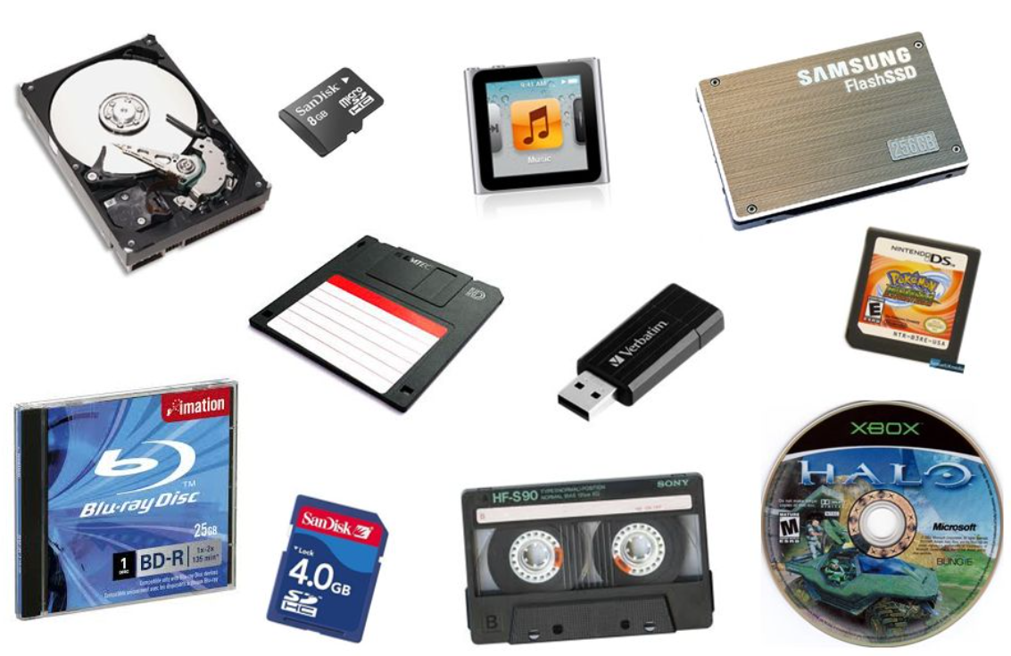  Guide learners to discuss the capacities and write speeds of the storage devices.  - Hard Disk Drives (HDDs): HDDs can have capacities ranging from hundreds of gigabytes (GB) to multiple terabytes (TB). HDDs generally have write speeds ranging from 50 to 150 MB/s.  - Portable Hard Drives: portable hard drives have similar capacities to internal HDDs, also ranging from GB to TB. the write speeds of portable hard drives are similar to internal HDDs but can vary based on the connection type (e.g., USB 3.0 vs. USB 2.0).  - Optical Discs: CDs typically hold about 700 MB, DVDs hold about 4.7 GB, and Blu-ray discs can hold up to 50 GB or more. CDs have write speeds of up to 52x (where 1x = 150 KB/s), DVDs up to 16x (1x = 1.32 MB/s), and Blu-ray discs up to 16x (1x = 4.5 MB/s).  Let learners in their groups differentiate between the various HDDs  - Traditional HDDs vs. Solid State Drives (SSDs): traditional HDDs use spinning disks to store data, while SSDs use flash memory, making them faster and more durable but typically more expensive.  - Internal vs. External HDDs: internal HDDs are installed inside the computer, while external HDDs are connected via USB or other ports for additional storage.  Provide learners with images or examples of different storage devices and a table to fill in with the maximum capacities and typical write speeds.  Ask them to work in pairs to complete the table.  For learners who need extra help, provide a simplified version of the table with some information pre-filled.  Assessment  - What is the typical capacity range for a hard disk drive (HDD)?  - Compare the write speeds of an HDD and a Blu-ray disc.  - How much data can a standard DVD hold? |  |  |  |  | Examples or images of various HDDs, portable hard drives, and optical discs
PHASE 3: REFLECTION | - What is one advantage of an SSD over a traditional HDD?  - Why might someone choose a portable hard drive over an internal HDD?  Use peer discussion and effective questioning to find out from learners what they have learnt during the lesson.  Take feedback from learners and summarize the lesson.

